**Places Grouping**

***Work-flow to Use Places Grouping***

The Places Grouping preference is accessed through **Load Template**



There is only one template available, and only one instance of it is permitted



***Preference Overview***

"Places " are usually stops and depots. Optimization can be improved by creation of groups of "sufficiently close places" and treating such a group internally, as "one place". This preference sets criteria for "sufficiently close" for place grouping.

***Templates Available from Optibus***

***Places Grouping***

**Purpose:**

As stated in the Overview. **Prerequisites:** None. **Opening Dialog:**

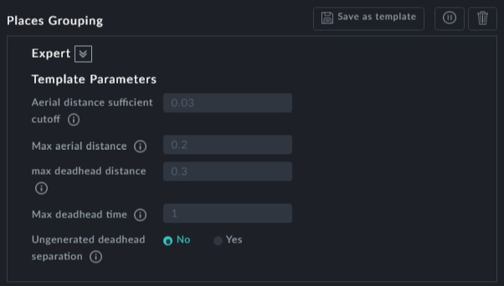

**Points to note:**

**Aerial distance sufficient cutoff**: Aerial distance less than this is "sufficiently close"



to be "the same place"

**Max aerial distance**: Aerial distance more than this is not "the same place"



**Max deadhead distance**: Deadhead distance more than this is not "the same place" **Max deadhead time**: Deadhead time more than this is not "the same place" **Ungenerated deadhead separation**: A generated deadhead trip between stwo stops



without a generated true prpoerty wil never be considered to be in "the same place"